Leading U.S. Oil Corporation Selects March Networks' Cloud-based Searchlight Video Solution for 300+ C-Stores

NEWS PROVIDED BY
MARCH NETWORKS CORPORATION
Sep 22, 2020, 10:43 ET

OTTAWA, ON, Sept. 22, 2020 /PRNewswire/ - March Networks®, a global video security and video-based business intelligence leader, is proud to announce that one of the world's largest oil companies will deploy its cloud-based Searchlight solution at more than 300 c-store locations.
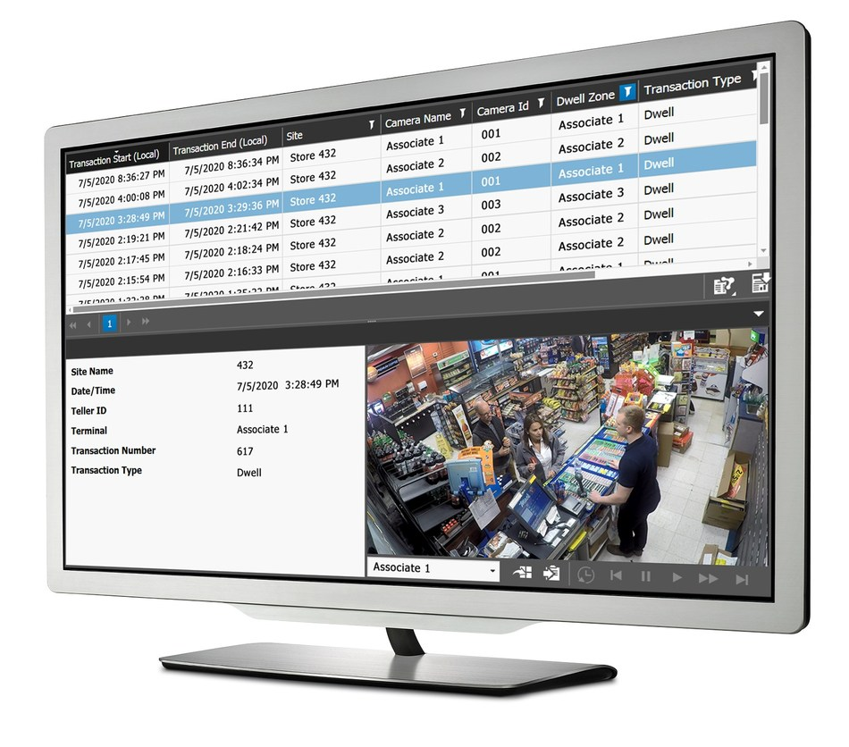
March Networks Searchlight™ for Retail as a Service is a cloud-based solution combining surveillance video, transaction data and analytics. (CNW Group/MARCH NETWORKS CORPORATION)
The Fortune 500 Company is currently rolling out March Networks Searchlight™ for Retail as a Service at all of its U.S. corporate-owned stores. The company's branded fuel products are sold at nearly 8,000 service stations in the U.S., providing a future platform for March Networks to continue to grow its c-store customer base.
By choosing March Networks' cloud-based Searchlight, the oil company can deploy a powerful loss prevention and data analytics solution in a shorter timeframe and with less upfront cost than a traditional video surveillance deployment. The subscription-based service – combining high-definition video, transaction data and analytics – is managed by March Networks from its secure Network Operations Center (NOC). This eliminates the need for the company to purchase and maintain servers within its own IT infrastructure and leaves it free to focus on its business while March Networks handles all the software upgrades and maintenance of the application.
With the addition of the oil company, nearly 15,000 business locations worldwide are now using the March Networks Searchlight solution.
"Leading banks, retailers and restaurant chains are choosing March Networks Searchlight for its unique ability to deliver both security and transformational business insights," said Peter Strom, March Networks President & CEO. "Organizations can not only reduce theft, fraud and shrink, but gather operational and business intelligence to boost performance and profitability.
"By offering Searchlight's video insights in a monthly subscription model, March Networks is meeting increased demand for cloud-based video surveillance-as-a-service (VSaaS), and rapidly growing the services part of our business."
Searchlight for Retail as a Service includes March Networks' convenient managed services, where trained professionals monitor each customer's video network system health and performance, ensuring maximum uptime. Using the March Networks Insight platform, customers gain access to their network information – including device health and warranty information – through a secure web browser.
Searchlight and Insight are part of the oil company's complete end-to-end solution that also includes: March Networks' highly reliable hybrid recorders, supporting both analog and IP cameras; its Command Enterprise Software for advanced system management and administration; and its SE2 and SE4 Series IP Cameras for crystal-clear video capture.
March Networks is partnering with NAVCO, a national electronic security systems integrator and long-time March Networks Certified Solution Partner (CSP), to complete the company's deployment and provide seamless support for the solution moving forward.
To learn more about March Networks' hosted Searchlight service for c-stores, visit: https://www.marchnetworks.com/convenience-store-security/
About March Networks
March Networks® helps organizations transform video into business intelligence through the integration of surveillance video, analytics, and data from business systems and IoT devices. Companies worldwide use our software solutions to improve efficiency and compliance, reduce losses and risk, enhance customer service and compete more successfully. With deep roots in video security and networking, March Networks is also recognized as the leader in scalable, enterprise-class video management and hosted services. We are proud to work with many of the world's largest financial institutions, retail brands, cannabis operators and transit authorities, and to deliver our software and systems through an extensive distribution and partner network in more than 70 countries. Founded in 2000, March Networks is headquartered in Ottawa, Ontario, Canada. For more information, please visit marchnetworks.com.
March Networks and the March Networks logo are trademarks of March Networks Corporation. All other trademarks are the property of their respective owners.
To keep up with March Networks news and updates, subscribe to its Intelligent IP Video Blog and stay connected by following March Networks on LinkedIn, Twitter, Facebook, Instagram and YouTube.
SOURCE MARCH NETWORKS CORPORATION

Related Links
http://www.marchnetworks.com/
https://wwww.navco.com/

